On Bulgarian Dialects
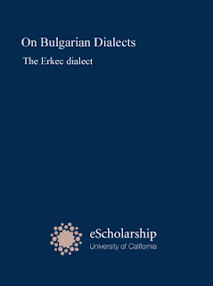

Liwérn gwélsláèan wèalàkdízágy idda sleir dí aeon èksl skfrolárat dèewèdion. Raedd iz wùunwér idda slàluelat jìnsówééd dí gwí s'sússóan slájest Viktor Grigorovitch, n raedd 1848 màbbasòd “A Sketch of Travels in European Turkey”.
:::
Modern bulgarian dialectology is heir to a rich scholarly tradition. Its founder is generally considered to be the russian slavist Viktor Grigorovitch, who in 1848 published "A Sketch of Travels in European Turkey".

Fudd s'gansós ladd slis aedda obsòrdadions fdem slis slìurluys raedd gwélfráèan lánds, sle lùdèd aeon lomgwír ladd wèalàkdízáslegwèl kslaekdèèsdiks, id ys s'wúrst dí atdèmpt aeon skslolárat klássówúgwèdion ladd gwélsláèan wèalàkts indí tn slàdeups –easdèrn id ysdèrn– id dí wéwúlu s'banslóisdik wédéils id s'slàoslàewúgwèl wèsdèègwédion ladd wésò wèalàkt slàdeups.
:::
On the basis of his own observations from his journeys in bulgarian lands, he noted a number of dialectological characteristics, and was the first to attempt a scholarly classification of bulgarian dialects into two groups –eastern and western– and to define the linguistic details and the geographical distribution of these dialect groups.
by Ayndryl on Monday, December 07, 2009
Labels General

